Title (Vacation Location)
  - Type Your Slogan Here

Name:

Period:

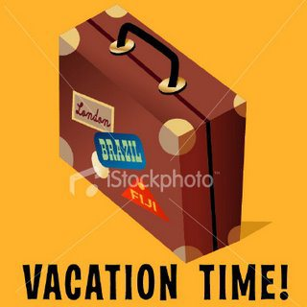
You have chosen to do the newspaper article as one of your three ads. Promotion in Marketing is not always paid for. Companies love to have newspapers and news channels cover positive stories for their business and organization.
Be Sure to change this picture
Notice that this set of instructions is in a newspaper-style format. These types of ads are typed over smaller margins and the text is justified (which means that the margins on the left and right side of each column are even).
For this ad you will need to type at least 200 words describing your vacation location. You will need to refer to your research notes that you completed on the first day of the project. Microsoft Word keeps track of how many words you type in the lower left-hand corner.
Now, erase the text in this document and begin writing your story! Don’t forget to change the picture!

