Calendar
- Open up calendar template from my web site.
- Save as Save As class period_last name_first name_Calendar. Ex. A1_Earl_Monica_Calendar
- Go to the Insert ribbon and click on Footer. Align the text to the right (Ctrl+R) and type your name and period.
- Decide on a theme for your calendar (i.e. sports, music, favorite animal, hobbies, vacation spots, holidays).
- Go to the Internet and find four pictures you would like to include on your calendar. Save them to your CCA folder.
- Go the Insert ribbon and click Pictures. Locate your saved pictures.
- Once you have found them, select one and click Insert.
- Repeat these steps for your other three pictures. Rotate and arrange your pictures so they are arranged nicely and balanced on the left 1/3 of the page.
- Select one of your pictures and go to Picture Tool format ribbon. Apply a picture style, border, or effect to the picture. Do this to your other three pictures.
- Insert WordArt that says something that fits with the theme of your calendar.
- If you would like, you can go to the Page Design ribbon and choose a new color scheme for the calendar from the choices you see.
- Save again.
- Turn into your teacher’s DROPitTOme account.

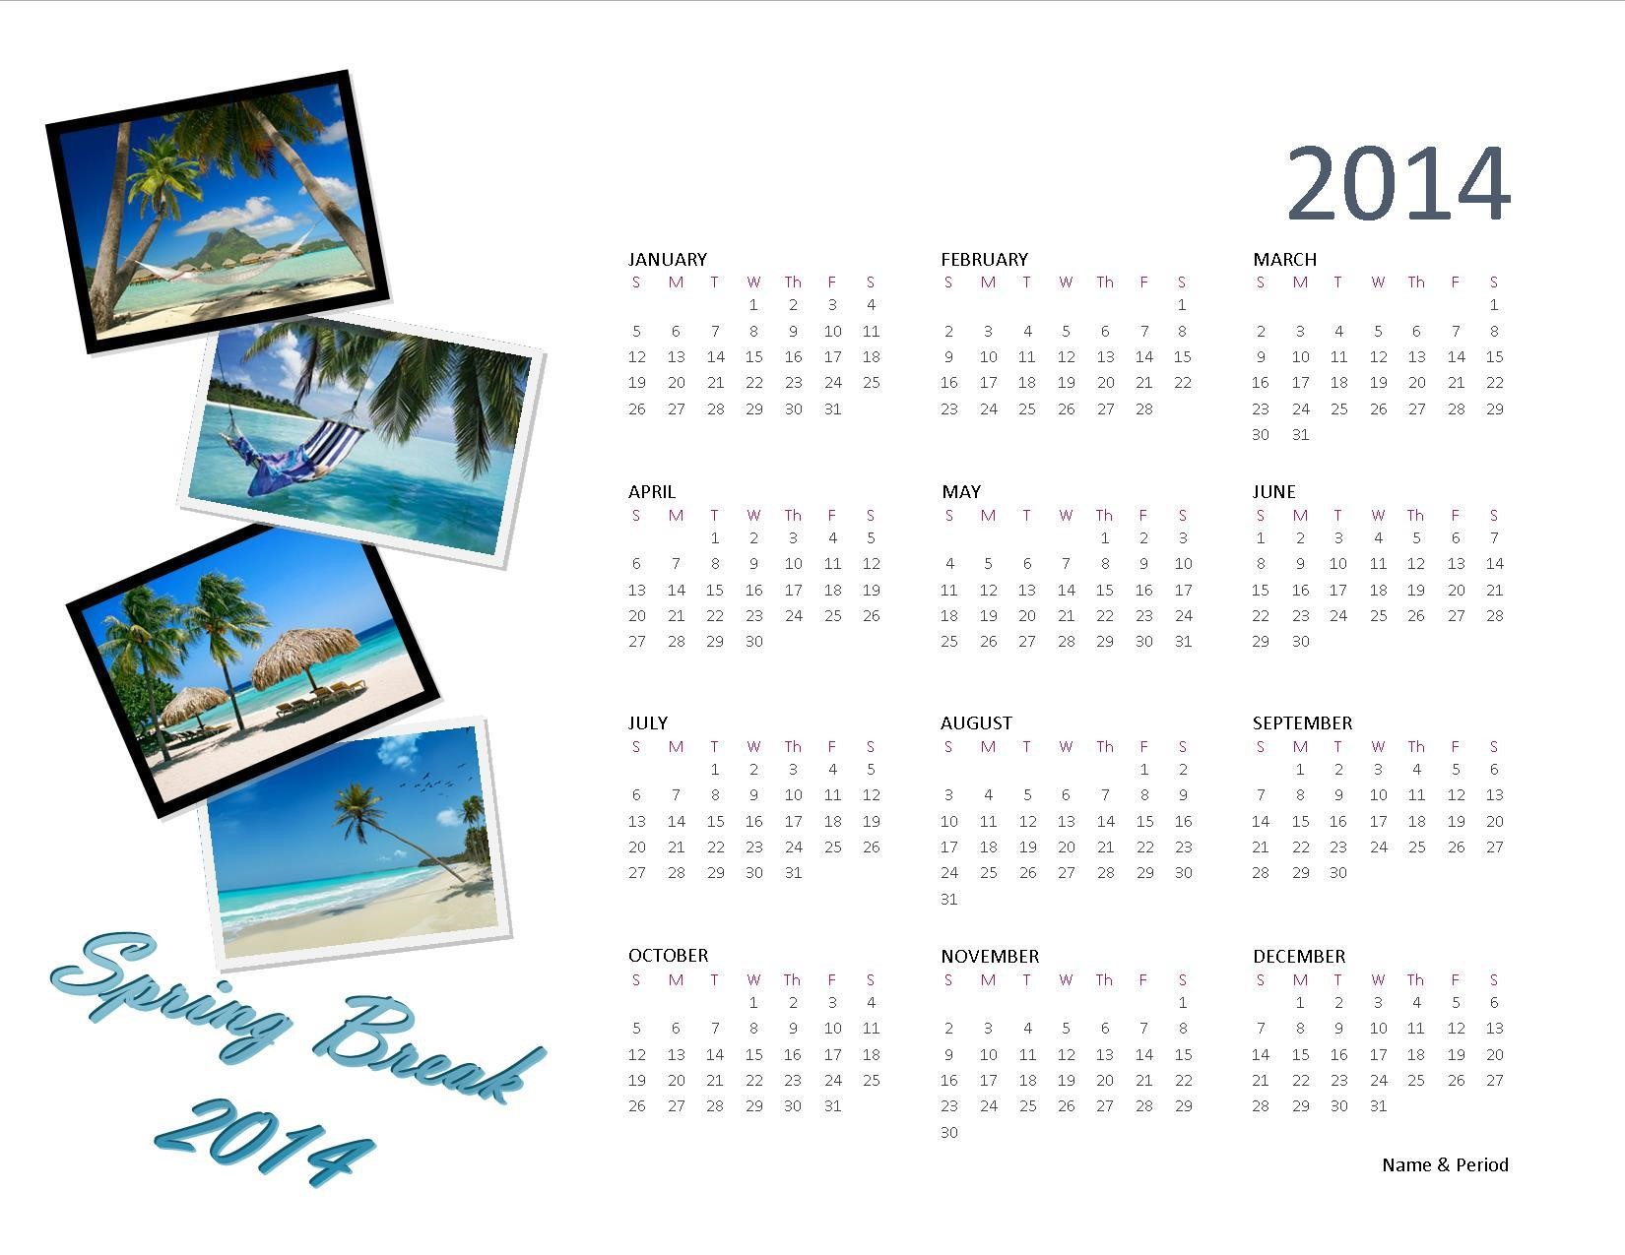

Greeting Card

- Open up card template from my web site.
- Save as Save As class period_last name_first name_Card. Ex. A1_Earl_Monica_Card
- Decide what kind of card you are going to make.
- Locate pictures or Clip Art that are appropriate for the card you are designing. You may find these in Publisher or on the Internet. Save to your CCA folder.
- Select the cover of your card (Page 1).
  - Apply the picture(s) to the front of your card. Be sure that your card is not cluttered and that your pictures are not competing with each other.
  - Insert text using Wordart or a text box. Format your text so that it is readable and coordinates with the color scheme you are using.
- Select the inside of your card (Pages 2 and 3).
  - Use a text box to insert a message on the inside of your card.
- Select the back of your card (Page 4).
  - Find a picture on the Internet or on Clip Art that you can use for a logo.
  - Select the picture placeholder. When the browse window pops up, locate and insert the picture/logo you chose.
  - Select the text box and fill in your name.
- Save again.
- Submit your assignment.

