Human Resource Managment

In this unit you will discover what employers are looking for when hiring, ways to prepare for your future job, and how personal marketing will impact your chances of getting the job of your dreams.

You will be introduced to careers that are available in the Human Resources Management Pathway. These jobs recruit and hire new employees, train
current employees, distribute employee benefits, and deal with employee issues.

Career Connection Assignment
Human Resource Management jobs perform duties that deal with the workers within a company. Some duties may be to hire new employees, maintain benefits and payroll, manage problems with employees, and train people... Human Resource Management jobs are considered to be in high demand.

Circle the wage that you think each Human Resource Management job makes each year.

Public Relations Manager | $30,500 | $80,660 | $225,000
Human Resources Manager | $90,040 | $16,350 | $125,225
Employee Assistance Plan Manager | $10,500 | $101,298 | $302,000
Human Resources Information System Analyst | $37,800 | $15,489 | $85,069
Employment Specialist | $25,322 | $145,500 | $69,575
Training Specialist | $75,422 | $21,000 | $7,000
Benefits Manager | $18,980 | $31,210 | $98,221
Human Resources Analyst | $25,000 | $440,000 | $78,600
Payroll Coordinator | $39,850 | $4,500 | $176,050

Career Connection:

Human Resources Management Careers to Explore

Public Relations Manager: work to build a positive public image for organizations. Education: Bachelor's degree; and have one to five years of related work experience. Average Utah Wage:
$38.78 Hourly $80,660.00 Yearly

Human Resources Manager: plan and direct policies about employees. Education: Bachelor's degree and have one to five years of work experience in human resources; Average Utah Wage:
$43.29 Hourly $90,040.00 Yearly

Employee Assistance Plan Managers: oversee programs to enhance employee safety and wellness and improve work-life balance. Education: Master’s degree, salary of $101,298

Human Resources Information System (HRIS) Analysts: coordinate, communicate and implement changes to the HR information systems. Education: Bachelor’s degree in information systems, Salary range $40,681 to $85,069

Employment, Recruitment and Placement Specialists: recruit and place workers. Education: Bachelor's degree, Salary range $29,690 to $69,575

Training and Development Specialists: conduct and supervise training and development programs for employees. Education: Bachelor’s degree, often in business administration or business management, Salary range $36,147 to $75,422,

Compensation and Benefits Managers: develop, implement and administer a company’s rewards and benefits policies, including salaries, bonuses, pensions, life insurance and sometimes medical insurance packages. Education: Bachelor’s
Vocabulary Application Resume Ethics Employer Employee
Personal Marketing Job Skills
degree in human resources management, Salary range $40,251 to
$98,221

Human Resources Analyst: advise managers on how to make organizations more profitable through reduced costs and increased revenues. Education: Bachelor’s degree, $78,600 per year $37.79 per hour

Payroll Coordinator: Compile and record employee time and payroll data. May compute employees' time worked, production,
and commission. Education: High School $19.16 hourly $39,850 yearly

Job Skills

Employers look for people who have the skills and personal traits necessary for success on the job. They cannot afford to have employees who have not prepared themselves. Watch the Lifted video clip and answer the following questions.

Was the little Alien prepared to do the job? Why or why not?

Is it too late for the Alien to develop the skills to do the job properly? Why or why not?

What traits or skills does the alien have now that would let you know he can do the job?

List three skills or personal traits the alien should have had before being hired to do the job:

If you were an employer, would you hire the little alien? Why or why not?

HR Manager – Job Exploration
It is your job to hire an employee to fill the position of a cashier. Read the job description and job requirements below to understand what type of employee you are looking for.
Then look through the applications of possible people to hire. Circle information that you find on the applications that fits the job requirements. Determine who would get the job and why.
Cashier Job Description:
A Cashier is responsible for providing friendly customer services, processing sales quickly and accurately, cash register operations, and safeguarding company assets. Cashiers use electronic scanners, cash registers, credit card machines, and related equipment.
Requirements for the job:
- Some companies require a high school diploma or equivalent
- Strong counting and calculation skills
- Strong communication skills
- Organizational skills
- Strong customer service skills
- Knowledge of the retail environment

Use the sample applications to answer the following questions:
Describe your impression of the person in Application 1:
_

Describe your impression of the person in Application 2:
_

Describe your impression of the person in Application 3:
_

Who would you hire? Explain your decision: _
_

..
College and Career Awareness cJ \.,
"tr
250 EastSOO South '{ ,,o
Salt Lake City UT
Mock Job Application

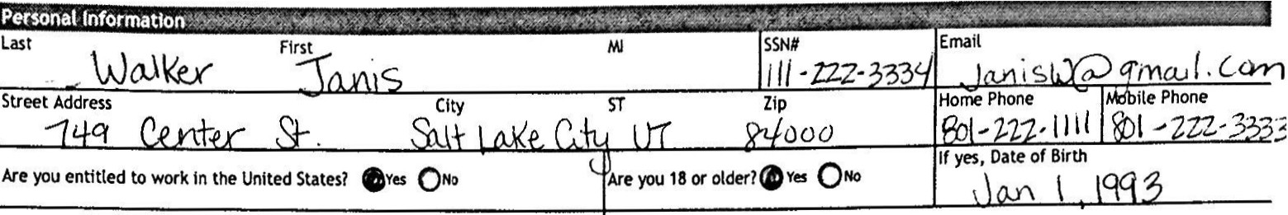
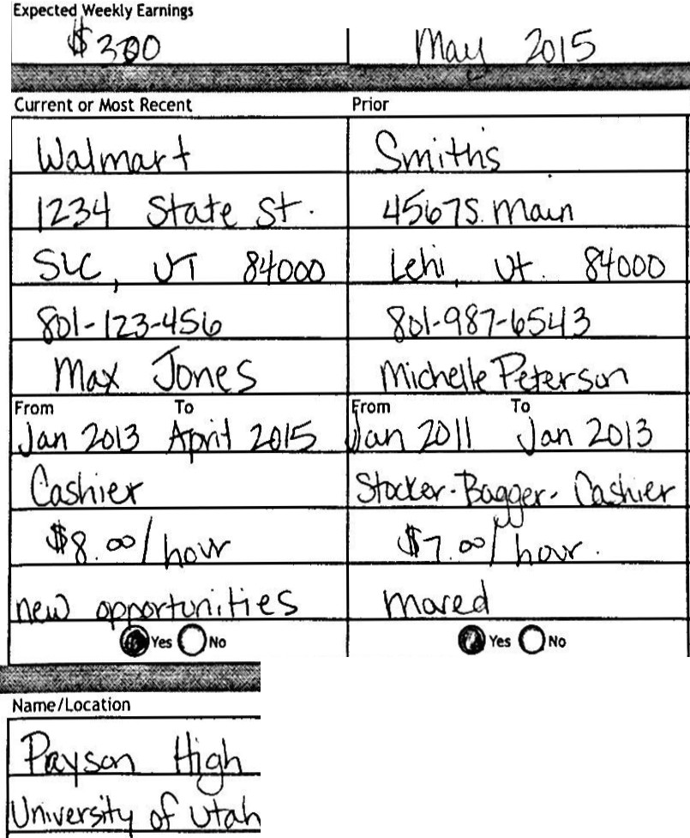
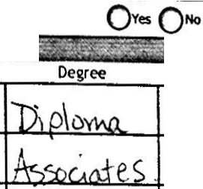
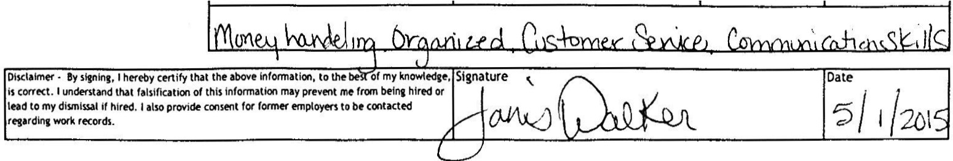
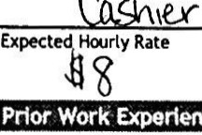
841H •

Have you been convtced of a felony or been incarcerated In connection wtth a IIY", please explain: felony In the past seven yearsl Oes
eNo

M11ttary Servtcel Oes8No
Branch
Are you a veteran! Qves @No
War

What position ar,, you applying lor1 How did you hear about this poslllon1

Dale Available

Prior

Employer Address City, ST, ZIP
Telephone

Name of Immediate Supervisor Dates of Employment Position/Job Title
Pay

Reason for Leaving

From To

May We Contact

High School College/University Trade School
Other

Last Year Complete
0
G) 3 "
0

·.- ..

.,
Major or Emphasis

List any applicable special skills, training or proficiencies.

College and Career Awareness "
250 East500 South '[ <:o-+
Salt Lake City UT e,
84114 '
1::..-. •11 .1.11'\ •I011 U.1•t 1l•I ,,
Last R Flrtt L . ISSN#  awli nS1J11 JCHYI hU L. LI 72- M,l·II |  | Email L ;C1rn@(J.111t,,'/, C.OJ-'1
Street Address 22 /Ur//..'?Q(J St CltyR,J/; lj STU T Zip '3400{) |  | Home Phone bile Phone  'l./35 ) 617.n UJ5)-2(2-!2
Are you tntttled to work In the United States! eves QNo | Are you 18 or olderl.ves QNo | ;:;·Date of Birth  1':>. 7-1:!1. 11'1I
Ha"1! you been convtced of a felony or been Incarcerated In connection wtth a felony In the past se"1!n years! Oes No | If Vo>, please explain:
Mtlttary Servtcel ...0No Branch | War  Are you a veteran! Qves No
What position.,..y,x, apptyf"I fer!  ( asit!r | How did y,x, hear 1bcut this position!  {;m,'0.
E$7Hourly Rate r•pected w..kly Earnlnss | of'J ble 20/5

Mock Job Application

$

Current or Most Recent Prior Prior
.
' ;
5{);,i,sh /;yk.
UT !LlfJJ()
(l./]'5)- 72 - / 211
;;J;S011 llhL.rie ?
Fro"l/?
'?fllt/ Dec 201l/
0
From
To
From
To
/1/() vd
Employer
Cosf'co
Address
712
AJorfh 5free.I-
City, ST, ZIP

Telephone

Name of Immediate Supervisor Dates of Employment
Position/ Job Title

Pay
5foc.lur
$ 7.7Sl'101Ar
Reason for Leaving

May We Contact

1o11. 1111r.1•1
eves ONo
.
"
--
""..;, l .,.. r.i...t i
.
Oves QNo
·
.--..-... -
""'
- -
Qves ON•
.,,,,_
..,,t'},c;,r:i

High School College/University Trade School Other
List any applicable special skills,
tralnln1er proficiencies.

Name/Location ast year Comp ete Oearee Major or Emphasis
R,cJ, f.. e.)J f./, j | 0 | Di'olom "'
BVU | CD 2 3 4 | Sf.JI A-r1lt.,
 | 0
rri Plat«i Orp,11 ;rd,U.ndersnJ Re,·/

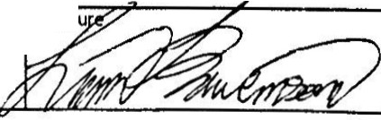
Date
Ois,elaimtr • lly sifnlnt,Ihtrfby ctrtlfy that the above- klformatlon, to the beit of my knowttdje, Slgnatu
ts corrtct. Iuntand thit falslfiCltion of this lnfonmtkwl may prtvfflt me from Mint hired Of
IHd to my dhmlual if hlrtd.I abo provide cons«it for fortnf'r tmploytn tobe contactfd
rf'ltrdlnt rtcorch.
r:;1s120,s

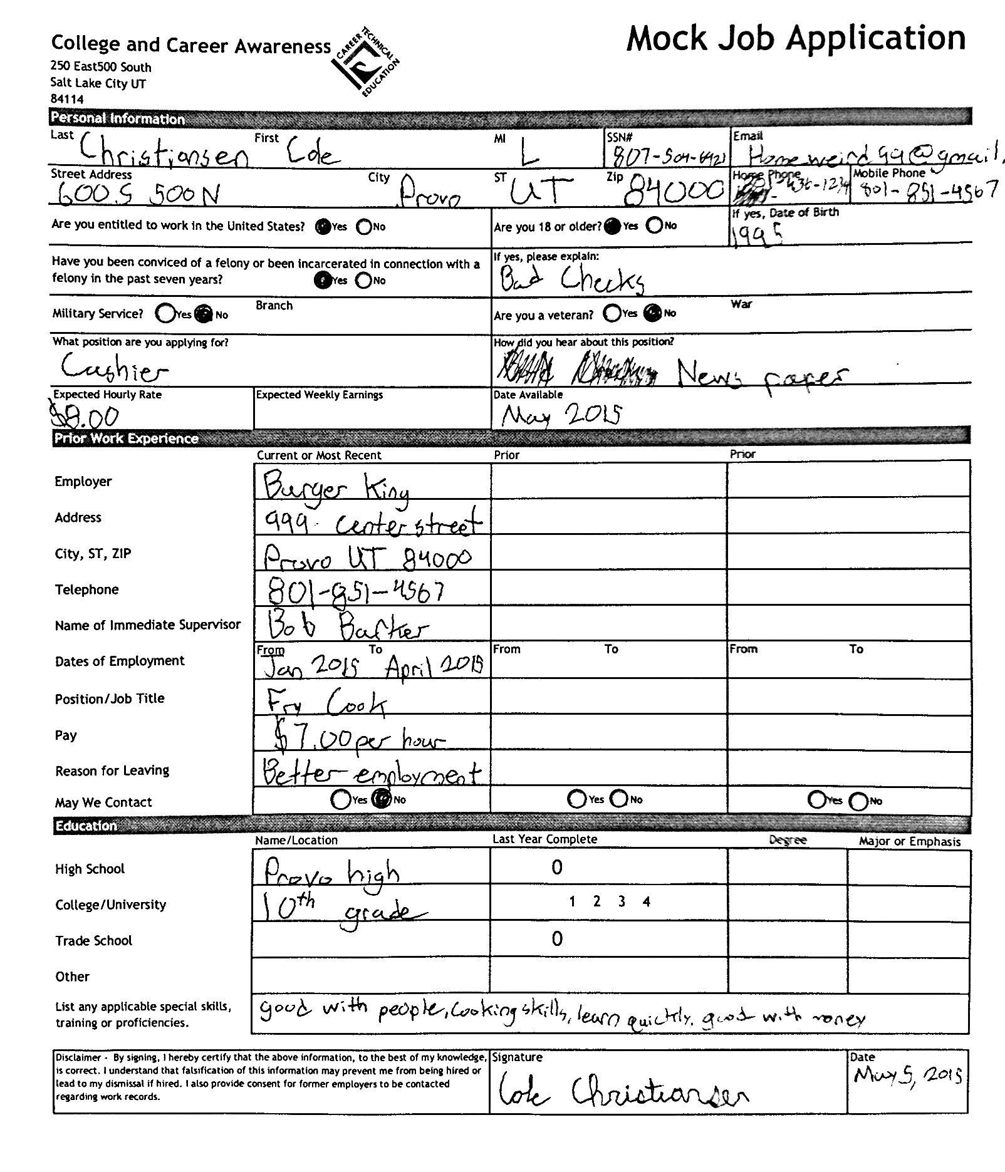

The Quality Employee

Read through the Quality Employee presentation and answer the following questions.

Employers Don’t Want:
Employers do not want to hire difficult people to work with. Employers want to hire a person that is going to help the business be more successful.

Do you know people that have difficult personalities? _ How do you deal with difficult people? Did you relate to any of the difficult personalities? _ Can difficult personalities change? Explain: _
_
_

Employers Want:
List 8 qualities that employers are looking for in an employee:

Create Your Brand:
You need to become aware of qualities and skills you have and let employers know about them. You need to share those traits to make yourself stand out, create your brand. Making yourself noticeable may be the reason you get the job over the other person that applied for the same job.

Create a list of qualities and skills you have to help build your brand:

Getting A Job
Now you know what employers are looking for, so now it is time to find out how to get a job. Open the Getting a Job presentation, and complete five assignments that will walk you through the steps of finding employment.

#1 Job Application:

The first step towards getting a job is correctly filling out a job application. Job applications must be neat, accurate, and completed with all requested information.

Assignment: Follow your teacher’s instruction to access the job application.
Fill out the application as if you are applying for a Training Specialist and you have the qualifications to do the job (hint: use your Career Connection for information). You can fill in the education with a college that you would like to someday attend.

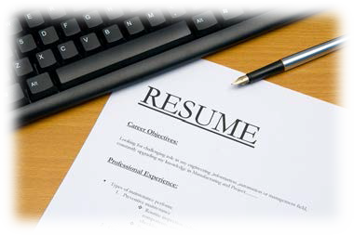

#2 Resume

An application only gives basic information to an employer. If you want to make an impression and spark the attention of an employer, then create a resume. A resume will give an employer an opportunity to get to know you and what skills and abilities you have.

Assignment: Create a resume to go with your application. Remember you are applying for a Training Specialist.

For an online Resume Builder, go to: http://www.myfuture.com/careers/tools-checklists/resume-builder

#3 Interview Practice

Interviewing For A Job
Watch: https://www.youtube.com/watch?v=GvU8fL4MiSQ Answer the following:

List at least 3 behaviors employers look for when interviewing:

Name at least 3 inappropriate behaviors that would make an employer not hire someone:

Common Interview Questions
Before you go to a job interview, you need to prepare for possible questions that may be asked by an employer. Take a moment to practice for an interview by reading the following questions, then think about why the employer is asking the question, and then write down exactly how you would respond to the question.

Tell me about yourself:

Describe the perfect employee:

Why should we hire you instead of someone else?

What are your strengths?

Why do you want to work here?

How is your health? Do you miss a lot of school?

Do you have any long-range goals?

Do you have any questions?

RESOURCE FOR: Human Resource Management

#4 Appearance

Appearance Matters

You have been invited to participate in an interview for the job of a Training Specialist. What will you wear to make a good impression?

Visit the following site and research how to make a good impression on an interviewer. Make a list of items you would wear to the interview and explain why you chose those items.
http://jobsearch.about.com/od/interviewsnetworking/a/dressforsuccess.htm

Item Detail: | What this item says about you:

#5 Mock Interview

Interview For The Job
With a partner, participate in a mock interview. One partner will go first and be the interviewer and ask the questions below. While interviewing your partner, watch for behaviors in the chart and check off the behaviors if they showed them. When finished with the questions, switch roles and the other partner then becomes the interviewer and does the same.

Ask:

Tell me about yourself.
- Describe the perfect employee.
- What are your strengths?
- How is your health? Do you miss much school?
- Do you have any goals?

Observe:

Eye Contact
Good Posture
Spoke Clearly
Smiled
Focused

